**Prototype**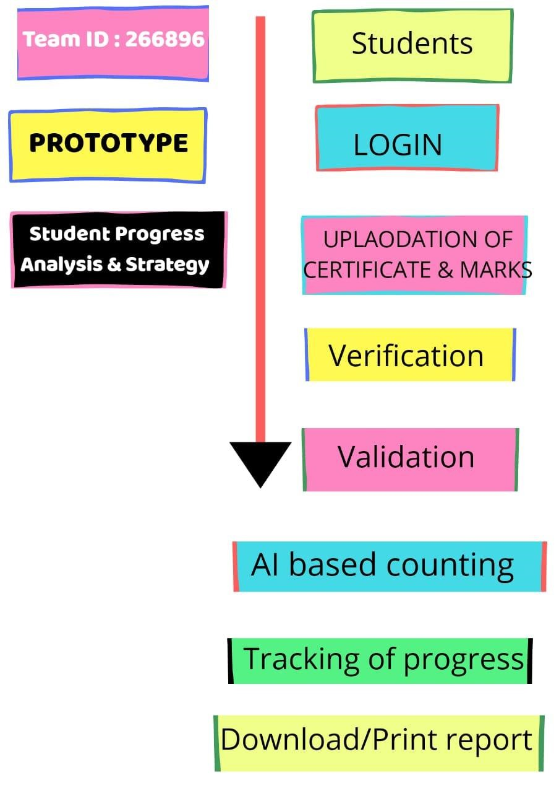

**Feedback:**

* **By using this web app faculty or administers observe their students’ progress and they can easily make a strategy to improve it.**
* **Parents can know their children’s attendances, marks or grad easily.**
* **Student can compare their progress to another student.**
* **By using this web app student can easily submit their work or project.**
* **Faculty can give important notice through this web app easily.**